H.T No
Regulations:
A22

Sreenidhi Institute of Science and Technology
(An Autonomous Institution)
Code No: 9BC01 Date: 07-July-2025 (FN)

B.Tech I-Year II- Semester External Examination, July-2025 (Regular and Supplementary)
ENGINEERING GRAPHICS (CSE,IT,CS,AIML,DS and IOT)

Time: 3 Hours Max.Marks:60

Note: a) No additional answer sheets will be provided.
b) All sub-parts of a question must be answered at one place only, otherwise it will not be valued.
c) Missing data can be assumed suitably.
Bloom's Cognitive Levels of Learning (BCLL)

Remember | L1 | Apply | L3 | Evaluate | L5
Understand | L2 | Analyze | L4 | Create | L6

Part - A Max.Marks: 6x2=12

Answer all QUESTIONS, EACH QUESTION CARRIES 2 MARKS.

 |  | BCLL | CO(s) | Marks
1 | What do you mean by conic section | L1 | CO 1 | [2M]
2 | Show the conventional representation of First angle Projection and Third angle Projection | L1 | CO 2 | [2M]
3 | Construct a Hexagon of side 30mm. | L1 | CO 2 | [2M]
4 | Define sectional plane. | L2 | CO 3 | [2M]
5 | What is isometric view | L1 | CO 4 | [2M]
6 | What is isometric scale? | L1 | CO 4 | [2M]

Part – B Max.Marks: 6x8=48
ANSWER ALL QUESTIONS. EACH QUESTION CARRIES 8 MARKS.

 |  | BCLL | CO(s) | Marks
7 | A fixed point is at distance of 55mm from fixed straight line trace the path of curve if eccentricity is e=2/3. Name the curve, also draw a tangent and normal to it at 60 mm from the directrix | L2 | CO 1 | [8M]
 | OR
8 | A Circle of 50mm diameter, rolls along a line for one revolution clock wise direction. Draw the locus of a point on the circle, which is contact with the line and draw a normal to the curve at a point 45mm from the directing line | L2 | CO 1 | [8M]
9 | A line AB, 90 mm long, is inclined at 45° to the H.P. and its top view makes an angle of 60° with the V.P. The end A is in the H.P. and 12 mm in front of the V.P. Draw its front view and find its true inclination with the V.P. | L3 | CO 2 | [8M]
 | OR
10 | A Line AB 70 mm long is inclined to HP at 45°, and to VP at 45°. Draw its projections when one of the end A is 20 above HP and 30mm infront of VP. | L2 | CO 2 | [8M]
11 | Draw the projections of a circle of 50 mm diameter having its plane vertical and inclined at 30° to the V.P. Its centre is 30 mm above the H.P. and 20 mm in front of the V.P. | L2 | CO 2 | [8M]
 | OR
12 | A hexagonal pyramid, base 25 mm side and axis50 mm long, has an edge of its base on the ground. Its axis is inclined at 30° to the ground and parallel to the V.P. Draw its projections. | L2 | CO 2 | [8M]
13 | A cylinder of diameter of base 35mm and axis 65mm long ,is resting on its base on H.P .It is cut by a section plane ,perpendicular to V.P. and inclined at 45° to H.P . The section plane is passing through the top end of an extreme generator of the cylinder. Draw the front view, sectional top view and true shape of the section. | L3 | CO 3 | [8M]
 | OR
14 | Draw the development of a pentagonal pyramid of base side 30mm axis length 65mm is sectioned by a plane inclined at 35° to HP and passing through midpoint of the axis of the cone. | L2 | CO 3 | [8M]
15 | Draw the isometric view of a cylinder of base diameter 40mm axis length 60 mm i) when its axis is vertical. ii) when its axis is horizontal | L2 | CO 4 | [8M]
 | OR
16 | Draw the isometric view of a cone of base diameter 40mm axis length 60 mm i) when its axis is vertical. ii) when its axis is horizontal | L2 | CO 4 | [8M]
17 | Draw the Front view Top view and side view for the following figure  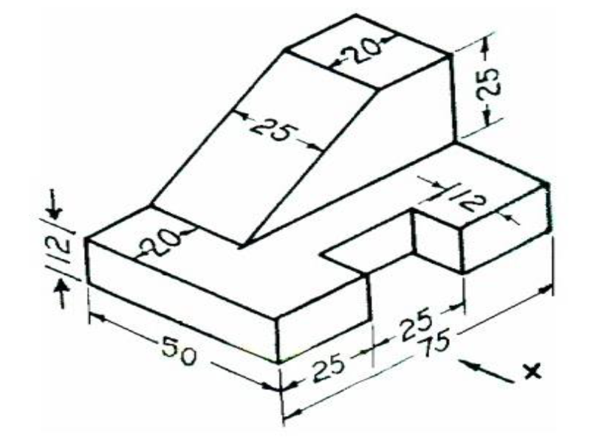 | L3 | CO 4 | [8M]
 | OR
18 | Draw the Front view Top view and side view for the following figure  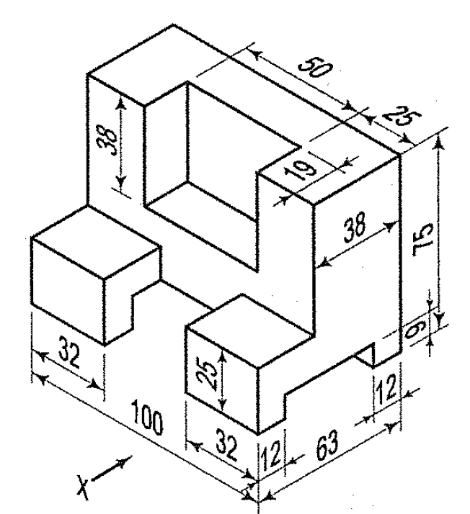 | L3 | CO 4 | [8M]

-- 00 -- 00 –

